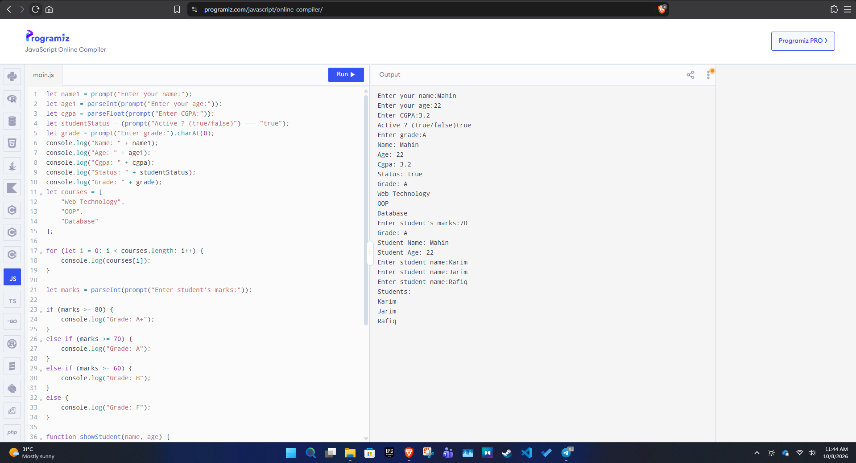
Fig: LAB 2 JAVASCRIPT OUTPUT SCREENSHOT

